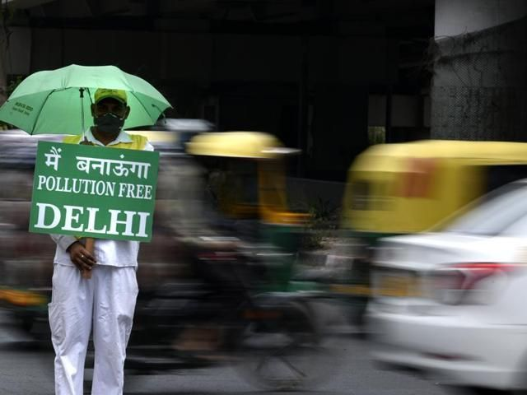
"Influencer Marketing is Dead"
"Push notifications can backfire"
"Campaign won awards but had no effect on Public health behavior"
"Children are being taught to plant saplings in school, but none of the plants survive"

For folks working with human behavior, these statements are less of a surprise, and more of a symptom.

Symptom of what's usually known as the Intention-Action Gap.

And then uncovering the context of why the gap exists in the first place.

Is Influencer marketing dead?
Not really, but evaluating influencer marketing with metrics that only evaluate eyeballs and engagement numbers, without asking "who is engaging" and "why are they engaging" creates the gap between what the brand needs vs what marketing efforts are achieving.

Do push notifications backfire?
If a shopkeeper keeps asking if you want 2 more samosa 4 times in a row after you just had a full meal, it would backfire on him too.
You can remind someone they must be hungry, you cannot create hunger after a full meal.

India's efforts to counter environmental concerns face the same bottleneck.

Lenses trained on existing frameworks of sustainable creates a gap that I like calling Framework-Context gap.

This then makes it super difficult to understand and solve for the Intention-Action Gap, even though one knows it exists.

Here's a simple example, from things I had learnt in 2019 simply by existing in Delhi -

Delhi knows it has a smog problem.
Their eyes, and throats burn, every year.
The cause is known, the effect is a yearly harsh reminder.
Stubble burning triggers, post Diwali spike, all is well known.
But Stubble must be burnt, and diwali must be celebrated.

Chalta hai. Kuch dino ki baat hai.

Why? because the cost of not fixing anything is disproportionately borne by those who have the least share of voice.

Those who can organize and influence things in the existing power structure, also happen to be the ones who can protect themselves from the consequences of things not getting better the most.

In fact, an entire economy of status around it is created.

5rs, 10rs, 15rs, 30rs, 100rs masks for the working class.

250, 300, 400, 1000rs masks for the elite.

Recycled products for cheaper a marker of not having money, but expensive air-purifiers at home signaling your wealth.

Our understanding of sustainability & wealth are fundamentally at odds with each other

Who would have thought?
Honestly, anyone who went to the people and talked to them about what they think and feel.

But no, we do not do that.
We like our ivory towers. We like our metrics. We like our methodologies & RCTs.

Logon se doori banake unki pareshaani nahi badal sakte.

